**PRACTICAL - 4**

**AIM:**

**Create the below given table and insert the data accordingly**.

**QUERIES:**

**(1) Retrieve all data from employee, jobs and deposit.**SELECT * FROM EMPLOYEE; 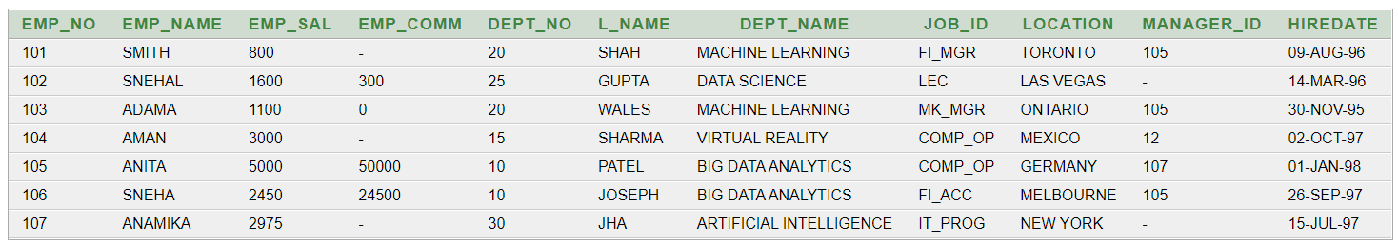  
SELECT * FROM JOB;

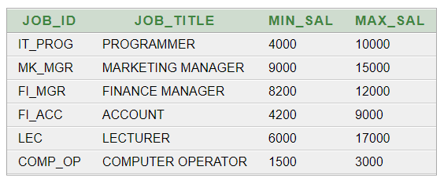

SELECT * FROM DEPOSIT2;  
  
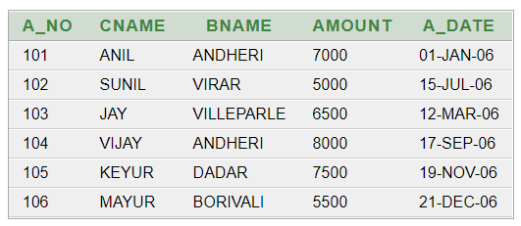

**(2) Give details of account no. and deposited rupees of customers having account opened between dates 01-01-06 and 25-07-06.**   
  
SELECT A_NO, AMOUNT FROM DEPOSIT2 WHERE A_DATE BETWEEN '01-JAN-06' AND '25-JUL-06';  
  
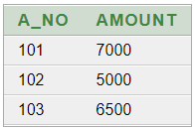

**(3) Display all jobs with minimum salary is greater than 4000.**   
  
SELECT JOB_TITLE FROM JOB WHERE MIN_SAL > 4000;



**(4) Display name and salary of employee whose department no is 20. Give alias name to name of employee.**   
  
SELECT EMP_NAME,EMP_SAL FROM EMPLOYEE WHERE DEPT_NO=20;  
  
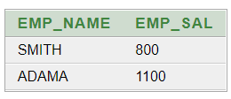

**(5) Display employee no, name and department details of those employee whose department lies in (10,20).**SELECT EMP_NO, EMP_NAME, DEPT_NAME FROM EMPLOYEE WHERE DEPT_NO BETWEEN '10' AND '20';

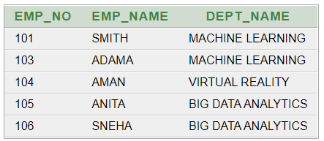

**(6) Display the non-null values of employees.**SELECT * FROM EMPLOYEE WHERE EMP_COMM IS NOT NULL;

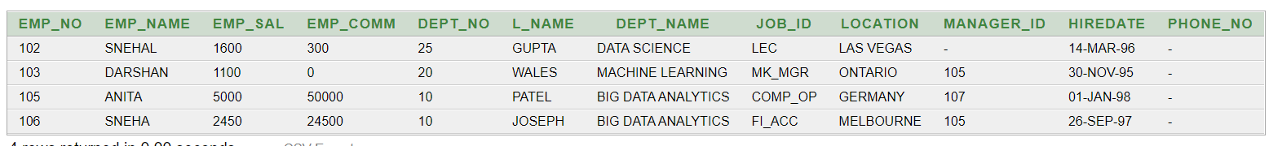

**(7) Display name of customer along with its account no (both column should be displayed as one) whose amount is not equal to 8000 Rs.**SELECT CNAME, A_NO FROM DEPOSIT2 WHERE AMOUNT != '8000';

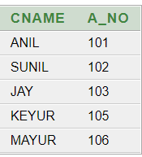

**(8)** **Display the content of job details with minimum salary either 2000 or 4000.**

SELECT * FROM JOB WHERE MIN_SAL=2000 OR MIN_SAL=4000;

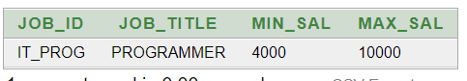

**To study various options of LIKE predicate**

**(1) Display all employee whose name start with ‘A’ and third character is ‘‘a’.**   
  
SELECT * FROM EMPLOYEE WHERE EMP_NAME LIKE 'A_A%';  
  


**(2) Display name, number and salary of those employees whose name is 5 characters long and first three characters are ‘Ani’.**   
  
SELECT EMP_NAME, EMP_NO, EMP_SAL FROM EMPLOYEE WHERE EMP_NAME LIKE 'ANI__';  
  
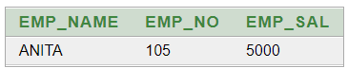

**(3) Display all information of employee whose second character of name is either ‘M’ or ‘N’.**   
  
SELECT * FROM EMPLOYEE WHERE EMP_NAME LIKE '_M%' OR EMP_NAME LIKE '_N%';  
  
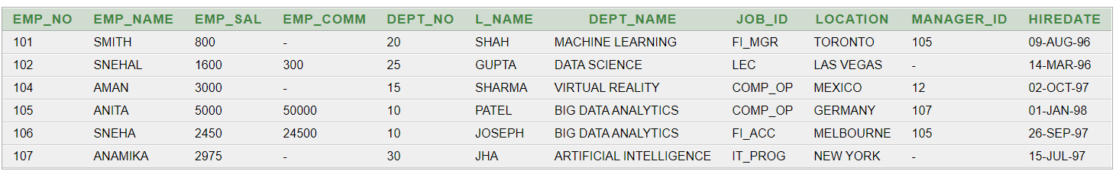

**(4) Find the list of all customer name whose branch is in ‘andheri’ or ‘dadar’ or ‘virar’.**SELECT CNAME FROM DEPOSIT WHERE BNAME IN ('ANDHERI', 'DADAR', 'VIRAR')

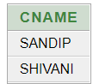

**(5) Display the job name whose first three character in job id field is ‘FI_’.**SELECT JOB_TITLE FROM JOB WHERE JOB_ID LIKE 'FI_%';

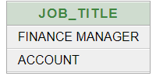

**(6) Display the title/name of job who’s last three character are ‘_MGR’ and their maximum salary is greater than Rs 12000.**SELECT JOB_TITLE FROM JOB WHERE JOB_ID LIKE '%_MGR' AND MAX_SAL>12000;

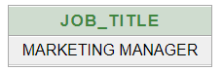

**(7) Display the non-null values of employees and also employee name second character should be ‘n’ and string should be 5-character long.**   
  
SELECT * FROM EMPLOYEE WHERE EMP_COMM IS NOT NULL AND EMP_NAME LIKE '_N___';



**(8) Display the null values of employee and also employee name’s third character should be ‘a’.**SELECT * FROM EMPLOYEE WHERE EMP_COMM IS NULL AND EMP_NAME LIKE '__A%';



**(9) What will be output if you are giving LIKE predicate as ‘%\_%’ ESCAPE ‘\’**

SELECT * FROM JOB WHERE JOB_ID LIKE '%\_%' ESCAPE '\';

